Women victims of gender based violence in Bulgaria
Bulgaria has never outlined for its gender or entrepreneur policies. When it comes to gender equality, there are some aspects related to Bulgarian cultural and historical heritage that have restrained the progress of this matter. Religion values, a traditional mind-set towards family structure and being a country that once took part of the URRS (Union of Soviet Socialist Republics) - with all the consequences that implies to its social structure – are some of the elements that has affected the way gender policies has been applied to this Balkan country.
In comparison to European country’s statistics, Bulgaria generally has still some issues to address as for entrepreneurial policies as well. Over the past decade, the self-employed rate in Bulgaria – A method used to measure the entrepreneurship activities – has remained below the average compared to the EU rate (11% in Bulgaria to a 14,3% for EU). As for youth and women, the gap is even wider when we compare it to EU numbers (3,7% to 7,8%) accordingly.
Moreover, the opposition of the Bulgarian government to ratify the Istanbul convention - An agreement in which almost all European agree on preventing and combating violence against women and domestic violence within its borders – based on a supposed violation of the Bulgarian constitution hasn´t helped to raise awareness and progress on the issue.
Nevertheless, due to COVID19, Bulgarian NGOs (e.g. Animus and Pulse foundation) have registered an increase in violence against women. Those claims have support the adoption of a national programme to prevent and protect women and children against domestic violence. On the other hand, there are no new policies focused on the support of women victims of gender-based violence in entrepreneurial activities in order to prevent their social exclusion.
This is inline with survey results, with a ratio of 58.82%, participants believe that women victims of violence are not well accepted within Bulgarian society. There is a stigmatisation due to the fact that these victims do not have help-seeking behaviour due to personal characteristics. However, in Bulgaria the societal context is far from understanding its role since there is a limited source of supportive help when women realized the intolerable behaviour of perpetrators and their responsibility to provide inclusive environments.
On the other hand, In terms of entrepreneurship, during the last decade and since the entry in the EU, Bulgaria has implemented several policies to boost entrepreneurial initiatives. Nonetheless, most of these initiatives are focused on a general basis and lack of the capability to target underrepresented or disadvantaged groups. Among these underrepresented groups we can find the collective of women who has suffered from gender based violence and that do not have not enough facilities to start their own business with a ratio of 74.51 % based on survey results.
With a ratio of 76.47 %, survey shows that it is necessary to create policies that address particularly their opportunities for entrepreneurship (e.g. Active discrimination programme). With a distinction to access to grants and funds particularly for this segment since this is the most crucial challenge for them in entrepreneurship with a ratio of 84.31 % based on survey. Which is understandable as survey results –see graphic 1- shows that all participants agreed that this segment group lack the opportunity to get funding due to gender inequality and therefore women victims of violence should be given more opportunities for it to star their own business.
Until now, there is no literature particularly covering the involvement of Victims of gender-based violence in entrepreneurship in Bulgaria. Therefore it is difficult to estimate how many of them have been enrolled in entrepreneurial activities. Nevertheless, the survey shows that less of 10% of this collective has experience an entrepreneurial activity. It is difficult to estimate how many women are being victimized since around 70–80% of cases pass under the radar, according to the Centre for the Study of Democracy estimates for 2015. Moreover, women who suffer from double discrimination as Roma women the rate of non-reporting is as high as 90% due to fear and lack of family or institutional support.
In terms of entrepreneurship, only 19 participants from the survey have known women from this collective who have businesses under the informal economy. Very few examples exist of women having their business in the formal economy in Bulgaria.
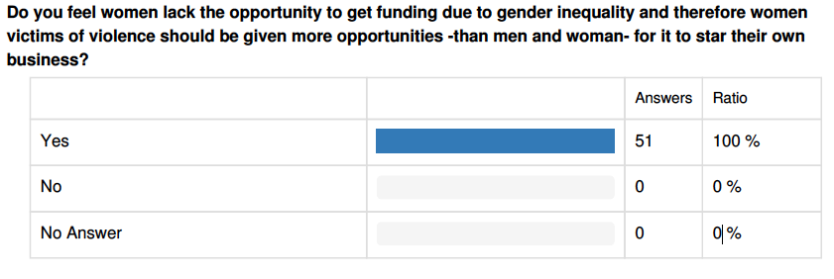
Graph 1. Results from survey regarding target group in entrepreneurship
Since every woman can be victim of this type of violence, no matter the age neither the social status, there is not a specific socio-demographic description for this collective. However, we can identify some common characteristics of this segment group that inhibit their interest and performance on entrepreneurial activities in Bulgaria:
- Economic dependence: As most of these women were or are involved in a toxic environment, it facilitates the creation of dependent dynamics. The economic dependence cannot allow these women to engage in new projects, whether they are personal or professional. Even when they left behind that context and they are ready for a new start, they see themselves still carrying the burden of economic dependence.

- Lack of support: Not only the lack of economic sources is a burden for these women, but the lack of information, family support, shelter and security can put these people in a risk situation. Social initiatives can help to solve these problems, however, they require civil and government involvement. With a ratio of 58.82% based on survey, it is believed that this is a crucial factor that cannot allow this target group to undertake entrepreneurial activities.

- Lack of self confidence: Not believing in themselves makes it more difficult for them to engage not only in entrepreneurial activities but also limit their range of action within their personal life context making the easiest decisions difficult to take. This lack of confidence is challenging one of the critical attitudes of entrepreneurs: “the risk-taking behaviour” that participants with 76.47 listed at the biggest barrier for this group to undertake entrepreneurial activities.
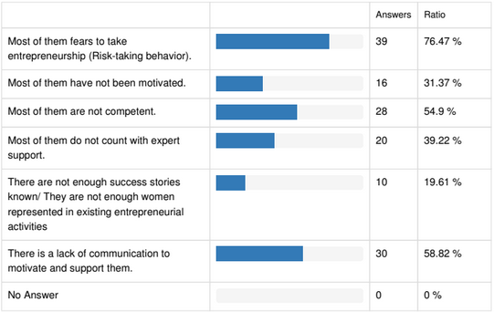
Graph 2. Barriers for Women victims of gender based violence in entrepreneurship
Based on graph 2, we can appreciate that the second and third barrier beside their individual characteristic of self-confidence is the lack of support from experts and education in entrepreneurship. The survey shows that the first aspect to address is the creation of policies but in second place there should be a bridge between professional working on entrepreneurship and the needs of this collective for support.
In terms of education, participants believe that this should be done by providing educative content that address the reality of business life in training programme or seminar. Also this content should address the development of skills for 4 important aspects: a better Communication, a better understanding of financial issues, developing skills for the creation of networking and a better understanding on how to create a business. Additionally due to the characteristics of this collective this learning needs to be guide by personal assistance since the most important factor is to create a trust environment for developing potential skills that entrepreneurs have such as risk-taking behaviour, creativity and so on.
Conclusion.
Whether the women has suffered from based gender violence or not, women in Bulgaria are still facing gender inequality and this inhibits them from getting engage with entrepreneurship. An aversion towards entrepreneur women, a culture based on traditional family values, the still fresh sequels of the old communist regime and the lack of interest of the government in gender based social policies deepen the breach for future Bulgarian women entrepreneurs. These aspects deepen even more for these women who has suffered from gender based violence and, therefore, suffer from other stigmas and are more vulnerable.
Furthermore, entrepreneurship for this collective seems to be a far-reaching reality since there are not particular policies that address this and there are very few isolated projects focus on it. However, policies and programs that aim to foment entrepreneurship can help this target group to become independent and therefore to avoid the perpetuation of perpetrators. For this to success, it is needed to implicate civil society and the government in one coalition to raise awareness for more direct policies for this collective.

Bibliography
Report for HBS & The World Bank (May, 2008). Female Entrepreneurship in Bulgaria. Retrieved from:
http://siteresources.worldbank.org/EXTECAREGTOPGENDER/Resources/FemaleEntrepreneursBulgariaWBHBSReport.pdf?resourceurlname=FemaleEntrepreneursBulgariaWBHBSReport.pdf
OECD/European Union (2017), The Missing Entrepreneurs 2017: Policies for Inclusive Entrepreneurship, OECD Publishing, Paris. Retrieved from: https://doi.org/10.1787/9789264283602-en.
Global Entrepreneurship Monitor Bulgaria Assotiation, Entrepreneurship in Bulgaria 2017, Dr Veneta Adonova with Mira Krusteff, Sofia. Retrieved from: https://www.gemconsortium.org/report/49920
OECD (2018), Inclusive Entrepreneurship Policies: Country Assessment Notes, Bulgaria 2018, OECD Publishing. Retrieved from: https://www.oecd.org/cfe/smes/BULGARIA-IE-Country-Note-2018.pdf
UNECE, Beijing + 25, National report of the Republic of Bulgaria, UNECE Publishing. Retrieved from: https://www.unece.org/b25_national_reports.html
CARVE, Responding to violence against women, CARVE Publishing. Retrieved from: https://asceps.org/makingprojects/carve-daphne/carve/
EIGE, Gender Equiality Index 2019:Published by EIGE (European Institute for Gender Equiality). Retrieved from: https://eige.europa.eu/publications/gender-equality-index-2019-bulgaria

Results are base on 51 responses from Bulgarian professionals working directly with Victims of gender-based violence or professionals supporting entrepreneurial services and activities.
The age of participants is mostly from 30 to 59 years old with at least technical studies and the majority with higher education -50.98%-. 76% of participants work in social sector and 60.78 % have worked directly with victims of gender-based violence. Furthermore, 54.9 % of participants have been involved in a sector that involves entrepreneurship.

